Variational Quantum Regressor (VQR)

1. Problem
In regression, the goal is to learn a function that maps continuous input variables (x) to a continuous output value (y ). Given a dataset ({(x_i, y_i)}), classical regression models (linear regression, kernel methods, neural networks) approximate this mapping by minimizing a prediction error.
A Variational Quantum Regressor (VQR) addresses this task using a parameterized quantum circuit whose parameters are optimized to minimize a regression loss function.

2. Intuition
VQR is the regression analogue of the Variational Quantum Classifier:
- Classical data is encoded into a quantum state
- A trainable quantum circuit transforms the state
- Expectation values of measurements are interpreted as real-valued predictions
- A classical optimizer updates circuit parameters
The model is trained in a hybrid quantum–classical loop, similar to neural networks but with a quantum model.

3. Circuit Structure
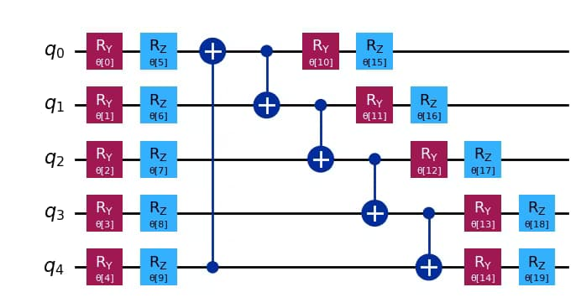
A typical VQR circuit has three layers:
- Feature Map
Encodes input features into quantum states using rotations and entanglement.
- Variational Ansatz
Parameterized gates (e.g., rotations + entanglement) with trainable parameters.
- Measurement
Expectation value of an observable (usually Pauli-Z) produces a real-valued output.
High-level flow:
[ x |(x) |(x,) ]

4. Simple Math Involved
- State preparation: [ |(x,)= U() U_{}(x) |0 ]
- Prediction: [ (x) = (x,) | O | (x,) ]
- Training objective: [ __i (y_i - (x_i))^2 ]
where (O) is a Hermitian observable (commonly Pauli-Z).

5. Python Code (Variational Quantum Regressor – Algorithm)
import numpy as np
from qiskit.circuit.library import ZZFeatureMap, RealAmplitudes
from qiskit.primitives import Sampler
from qiskit_machine_learning.algorithms.regressors import VQR
from qiskit_machine_learning.optimizers import COBYLA
X_train = np.array([
[0.1, 0.2],
[0.2, 0.3],
[0.6, 0.7],
[0.8, 0.9]
])
y_train = np.array([0.3, 0.5, 1.3, 1.7])
num_qubits = 2
feature_map = ZZFeatureMap(
feature_dimension=num_qubits,
reps=2
)
ansatz = RealAmplitudes(
num_qubits=num_qubits,
reps=2
)
optimizer = COBYLA(maxiter=100)
sampler = Sampler()
vqr = VQR(
sampler=sampler,
feature_map=feature_map,
ansatz=ansatz,
optimizer=optimizer
)
vqr.fit(X_train, y_train)
X_test = np.array([
[0.15, 0.25],
[0.75, 0.85]
])
predictions = vqr.predict(X_test)
print("Predicted values:", predictions)

6. Where the Algorithm Is Useful
- Regression on small-to-medium datasets
- Quantum machine learning research
- Function approximation and curve fitting
- Hybrid quantum–classical pipelines

7. Limitations
- No proven quantum advantage
- Training is slow due to many circuit evaluations
- Sensitive to noise and barren plateaus
- Limited scalability on current hardware

8. Comparison with Classical Regression
- Model: Classical regression uses explicit parameters; VQR uses quantum circuit parameters
- Output: Classical outputs numbers directly; VQR outputs expectation values
- Optimization: Classical gradients vs. hybrid quantum–classical optimization
- Scalability: Classical methods scale better today
- Practicality: VQR is mainly research-oriented

9. One-Sentence Summary
A Variational Quantum Regressor learns a continuous function by training a parameterized quantum circuit whose measurement expectation values approximate real-valued outputs.

